Namibia Helicopter Adventure
Otjinhungwa - Skeleton Coast - Damaraland - Swakopmund - Namib
13 Days / 12 Nights
Max 4

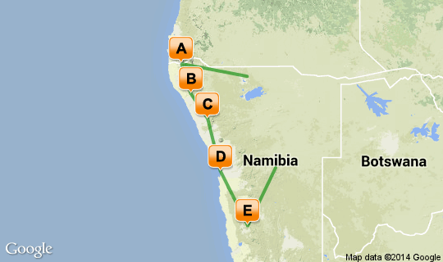

Click here to view your Virtual Itinerary

Overview
Expansive exploration of Namibia by helicopter

Destination | Accommodation | Arr. | Dep. | Nights | Basis
Otjinhungwa | Okahirongo River Camp | 26 Mar | 28 Mar | 2 | FI
Skeleton Coast | Okahirongo Elephant Lodge | 28 Mar | 31 Mar | 3 | FI
Damaraland | Desert Rhino Camp | 31 Mar | 3 Apr | 3 | FI
Swakopmund | Swakopmund Guesthouse | 3 Apr | 5 Apr | 2 | FB
Namib | Wolwedans Boulders Camp | 5 Apr | 7 Apr | 2 | FI

Key
RO: Room only. B&B: Bed and breakfast. D, B&B: Dinner, bed and breakfast. FB: Dinner, bed, breakfast and lunch. FB+: Dinner, bed, breakfast, lunch and activities daily. FI: Fully inclusive.

Transport

Flight Information:
Date | Flight | Departure | Time | Arrival
26 Mar | Heli | Ondangwa Airport |  | Okahirongo River Camp
28 Mar | Heli | Okahirongo River Camp |  | Okahirongo Elephant Lodge
31 Mar | Heli | Okahirongo Elephant Lodge |  | Desert Rhino Camp
03 Apr | Heli | Desert Rhino Camp |  | Swakopmund Guesthouse
05 Apr | Heli | Swakopmund Guesthouse |  | Wolwedans Boulders Camp
07 Apr | Heli | Wolwedans Boulders Camp |  | Hosea Kutako International Airport [WDH]

Day 1: Okahirongo River Camp, Skeleton Coast (Wed, 26 March)

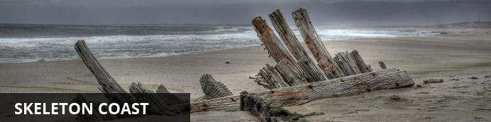
Known by the Bushmen as the "land God made in anger" the Skeleton Coast is remoteness at its best. Thousands of miles of sandy desert dotted with shipwrecks meet with the cold waters on the Atlantic and somehow an amazing array of wildlife and flora manages to survive in this harsh but beautiful environment.

After clearing customs and immigration at Ondangwa International Airport in the far north of Namibia, continue on to the domestic airport in Ruacana (on the Angolan border) where your heli and pilot will meet you.
We will fly west to Okahirongo River Camp, and the day can be spent relaxing in the comforts of the camp, enjoying a drive within the Marienfluss valley, and an afternoon scenic flight over the Kunene River.

2 overnights: Okahirongo River Camp
Okahirongo River Camp is an eco-friendly lodge built on a sweeping ridge and opening up to breathtaking views of the Kunene River. The central area, constructed above the rapids, comprises two lounges, a library and dining room, decked out in African elegance. The turquoise waters of the swimming pool spell out refreshment from the desert heat and the spacious sundeck invites sunbathing or simply delighting in the exotic grandeur of the natural surrroundings. Excellent Service, delicious African-Italian cuisine and exquisite South-African wines will round of your stay and make Okahirongo River Camp a most memorable safari experience.
Cleverly built into the rocky terrain, the four luxurious double tents, one twin tent and one family suite are constructed with wood and canvas and each have a magnificent view of their own. The interiors have been furnished with a minimalist African chic. Lavish four-poster beds, splendid indoors and outdoors showers and spacious decks guarantee utmost comfort and the exclusive right of being at one with nature. Fall asleep to the sound of the rushing river below – the perfect African lullaby.
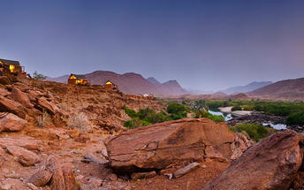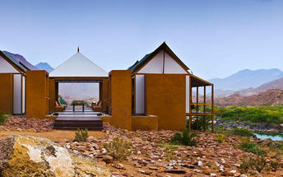

Included
Fully Inclusive
Drinks (Local Brands) Included

Day 2: Okahirongo River Camp, Skeleton Coast (Thu, 27 March)

We will spend the next 2 days exploring the Kunene region by helicopter – the impressive Epupa Falls on Kunene River, visiting remote Himba villagers and the Marienfluss valley, taking in some of the world’s most incredible
landscapes, rich wildlife and fascinating cultures.

Included
Fully Inclusive
Drinks (Local Brands) Included

Day 3: Okahirongo Elephant Lodge, Kaokoveld (Fri, 28 March)

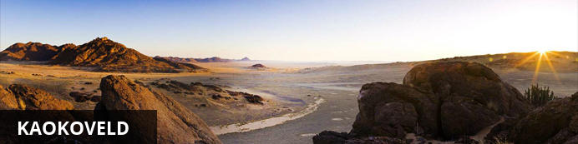
The Kaokoveld is a dry, mountainous and relatively undeveloped region that takes in the harsh beauty of the Skeleton Coast and the coppery sands of the northern Namib Desert. The area is inhabited by three main ethnic groups – the Damara, Herero and Himba people – each with their unique customs, traditions and rituals.

Today we fly south to the Purros Conservancy, bordering the Skeleton Coast Park. This rugged and sandy landscape is known to be one of Namibia’s most wild areas - home to lions, elephant and rhino. We will stay at Okahiringo
Elephant Lodge - the luxurious chalets are beautifully designed, blending in with the natural environment, and decorated in colours that reflect the desert scenery.

3 overnights: Okahirongo Elephant Lodge
Okahirongo Elephant Lodge is situated in the Purros Conservancy in Kaokoland, one of the last truly wild areas in the North West of Namibia and it features beautiful mountain landscapes and rugged tranquillity. Activities include game drives in open 4x4 vehicles, tracking the renowned desert adapted elephants, walks and visits to the local Himba village.
Okahirongo Elephant Lodge is located in the Purros Conservancy, 55km from the skeleton coast and around 200km south of the Kunene River in the north of Namibia. Often described as one of the last true wilderness areas, the Kaokoveld is home to the nomadic Himba tribe as well as uniquely desert adapted Elephant, lion, black rhino and giraffe.
The lodge, in the Purros Conservancy area, is a no risk malaria destination and can be reached by 4x4 vehicles. Alternatively a 2 ½ hour flight from Windhoek in a small aircraft will take you to our landing strip, which is located approximately 5 minutes from the lodge.
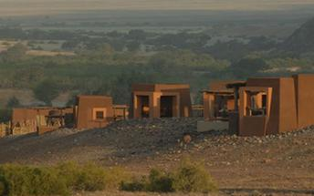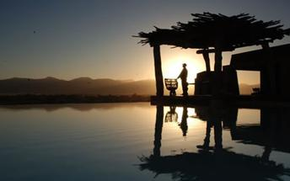

Included
Fully Inclusive
Drinks (Local Brands) Included

Day 4: Okahirongo Elephant Lodge, Kaokoveld (Sat, 29 March)

The next 2 days we will look for elephants and rhino, and tracking lion with Flip Stander who is an authority on lion research. We will enjoy a day tripto Moewe Bay on the coast, where we will have a unique opportunity to visit
Flip’s research station, and explore the coastline looking out for the Cape Fur Seal, sometimes seen surfing on the breaking waves. Fishing here is also fun – strictly catch and release - with catches including Cob, Steenbra and Blacktail.

Included
Fully Inclusive
Drinks (Local Brands) Included

Excluded
Excluded Not Available

Day 5: Okahirongo Elephant Lodge, Kaokoveld (Sun, 30 March)

Day Notes
Look for elephants and rhino, and tracking lion with Flip Stander who is an authority on lion research. We will enjoy a day tripto Moewe Bay on the coast, where we will have a unique opportunity to visit
Flip’s research station, and explore the coastline looking out for the Cape Fur Seal, sometimes seen surfing on the breaking waves. Fishing here is also fun – strictly catch and release - with catches including Cob, Steenbra and Blacktail.

Included
Fully Inclusive
Drinks (Local Brands) Included

Day 6: Desert Rhino Camp, Damaraland (Mon, 31 March)

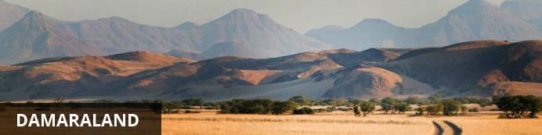
Huge, untamed and ruggedly beautiful Damaraland is an exceptionally scenic landscape of open plains and spectacular rock formations. The major attractions are Spitzkoppe, the Brandberg, Twyfelfontein, Vingerklip and the Petrified Forest.

Today we fly further south to Damaraland, found between the Skeleton Coast and the Central Plateau. We will stay 3 nights at Desert Rhino Camp which is located within Palmwag Reserve –an area rich in wildlife and home
to significant numbers of black rhino. The attractions include fascinating geological formations, unique vegetation and the largest collection of ancient rock art sites in Southern Africa.

3 overnights: Desert Rhino Camp View iBrochure
Desert Rhino Camp offers an original and exclusive wilderness experience and the possibility of seeing some of the largest free-ranging population of desert-adapted black rhino in Africa. The camp, set in a wide valley sometimes flush with grass, has eight large Meru-style tents with en-suite bathrooms. A tented dining and living area offers uninterrupted views of the desert and mountains, while extraordinary welwitschia plants dot the plain in front of camp.
Activities include rhino tracking on foot or by vehicle with Save the Rhino Trust trackers (an NGO responsible for the conservation of the black rhino in the area), full-day outings with a picnic lunch, birding and nature drives. Other species seen in the area include Hartmann’s mountain zebra, giraffe and lion. Desert Rhino Camp is run in conjunction with Save the Rhino Trust so in addition to gaining amazing insight into the ecology and conservation of this area, a portion of guest revenue goes to the Trust and its conservation operations.
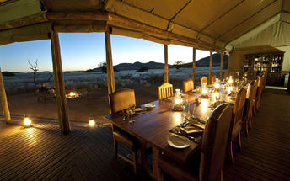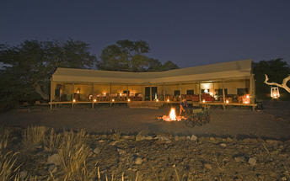

Included
Fully Inclusive
Drinks (Local Brands) Included

Day 7: Desert Rhino Camp, Damaraland (Tue, 1 April)

Desert Rhino Camp which is located within Palmwag Reserve –an area rich in wildlife and home to significant numbers of black rhino. The attractions include fascinating geological formations, unique vegetation and the largest collection of ancient rock art sites in Southern Africa.

Included
Fully Inclusive
Drinks (Local Brands) Included

Day 8: Desert Rhino Camp, Damaraland (Wed, 2 April)

Desert Rhino Camp which is located within Palmwag Reserve –an area rich in wildlife and home to significant numbers of black rhino. The attractions include fascinating geological formations, unique vegetation and the largest collection of ancient rock art sites in Southern Africa.

Included
Fully Inclusive
Drinks (Local Brands) Included

Day 9: Swakopmund Guesthouse, Swakopmund (Thu, 3 April)

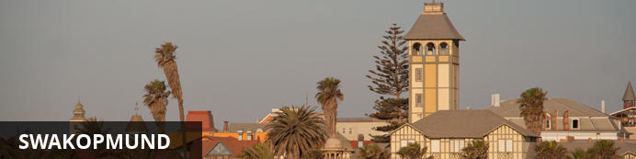
Founded in 1892 as the main harbour for German South West Africa, Swakopmund is often described as being more German than Germany. Now a seaside resort, Swakopmund is the capital of the Skeleton Coast tourism area and has plenty to keep visitors happy. The quirky mix of German and Namibian influences, colonial-era buildings and the cool sea breeze make it very popular.

Our destination is Swakopmund – Namibia’s premier holiday resort, located halfway down the Namibian coast, surrounded by the West Coast Recreational
Area. On route we will fly over Namibia’s highest mountain – the Brandberg – a dome shaped massif famous for the White Lady rock painting. Orabes Kopf is a prominent point where we will land to take in the incredible views to the south

2 overnights: Swakopmund Guesthouse
Situated in Swakopmund town centre and only a 5min walk from the beach and main shopping area, is the Swakopmund Guesthouse, owned and run by the Borg family. Previously used as a holiday home it has been completely revamped, in a very elegant and modern style. This particular bed and breakfast establishment caters for the more upmarket traveller. Most of their guests stay here because of high comfort levels, personalized service and the short distance to the beach!
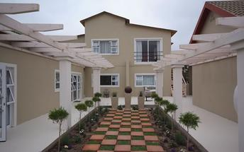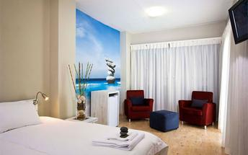

Included
Full Board

Day 10: Swakopmund Guesthouse, Swakopmund (Fri, 4 April)

We will enjoy the coastal resort of Swakopmund and some of the exciting activities including a private dolphin cruise followed by a barbeque on the beach.
Half a days shark fishing, and in the late afternoon, a quad biking tour in the amazing sand dunes is on offer, with sundowners looking over the ocean.

Included
Full Board

Day 11: Wolwedans Boulders Camp, Namib (Sat, 5 April)

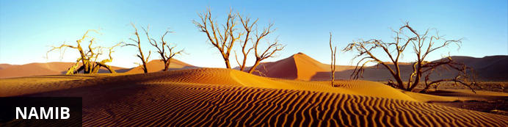
The Namib is the world’s oldest desert, and although it stretches along the entire length of Namibia’s coastline, the Namib commonly refers to the vast sea of sand from Luderitz to Swakopmund. For a big sandy desert the scenery is remarkably varied, with the giant red dunes of Sossusvlei being the most famous part.
Because of how old it is the Namib is home to numerous species that don’t occur elsewhere and although no humans live in the desert an amazing array of flora and fauna manages to survive here. Famous species include the Welwitschia – a living fossil plant, endemic chameleons, fur seals along the coast, brown hyenas, jackals and remarkably one of Africa’s largest antelope the Gemsbok. The name Namib is of Nama origin and means "vast place" and vast it certainly is.

Our final destination is Boulders Camp Wolwedans in the NamibRand Nature Reserve - south Namibia, located between the Naukluft Park and Nubib
mountain range. The game reserve, previously farmed land, is free of fences allowing wildlife to roam freely. Boulders Camp is the perfect base to explore
the NamibRand Nature Reserve by foot, safari vehicle and by heli. We will embark on a dawn flight over the Sossusvlei sand dunes - an exceptional way to finish your adventure.

2 overnights: Wolwedans Boulders Camp
From Boulders Camp you will explore the deep south of NamibRand Nature Reserve. Guided scenic drives, or two to three hour walking safaris treading along the ancient hunting grounds of the bushmen, will happily fill your days.
Boulders calls for a two night stay and is ideally booked in combination with one or two nights at any of the other camps in the dunes, which makes for the ultimate desert experience.
Self-drive guests spending their first night or whole stay at Boulders, park at farm Aandster farmhouse, where a guide will transfer them to Boulders, by open LandRover. Fly-in guests, utilize the landing strip at Aandster, and are transferred as above.
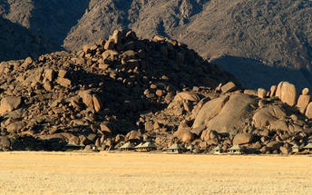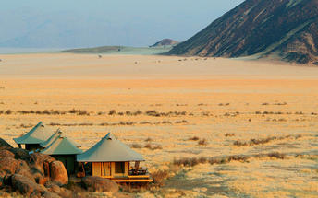

Included
Fully Inclusive
Drinks (Local Brands) Included

Day 12: Wolwedans Boulders Camp, Namib (Sun, 6 April)

Boulders Camp Wolwedans in the NamibRand Nature Reserve - south Namibia, located between the Naukluft Park and Nubib mountain range. The game reserve, previously farmed land, is free of fences allowing wildlife to roam freely. Boulders Camp is the perfect base to explore the NamibRand Nature Reserve by foot, safari vehicle and by heli. We will embark on a dawn flight over the Sossusvlei sand dunes - an exceptional way to finish your adventure.

Included
Fully Inclusive
Drinks (Local Brands) Included

Excluded
Excluded Not Available

Day 13: Departure (Mon, 7 April)

Departure with helicopter to Windhoek or Walvis Bay where the adventure ends
Departure with onward flight arrangements.

END

